**Future Insights: Predicting Highly Paid Professions and Building Pathways for Students**

**1. Product Idea**

My project is a career prediction platform that helps students identify and pursue highly paid professions using machine learning and data analytics. The platform provides:

- Career prediction dashboard (trends in high-paying jobs)

- Personalized career pathway guides (skills, exams, universities)

- Resource repository (scholarships, mentorship, courses)

- AI-driven recommendations (based on individual preferences, industry trends, and economic reports)

It bridges the gap between education and employment by offering real-time market insights and customized career roadmaps for students.

**2. Business Model**

Platform follows a multi-stakeholder business model, targeting:

- Students (primary users)

- Educators & Career Counsellors (for academic integration)

- Policy Makers & Institutions (for partnerships and validation)

Revenue Streams:

- Freemium Model: Basic career insights for free, premium services for advanced analytics and mentoring.

- Institutional Partnerships: Collaboration with schools, universities, and online learning platforms.

-Advertisements & Sponsorships: Industry partners promoting courses and job opportunities.

- Subscription Plans: Monthly/yearly plans for personalized career coaching and mentorship.

**3. Financial Model**

Financial model likely includes:

Revenue Projections:

- Free users converting to premium subscribers (~10-15%)

- Institutional licensing fees

- Affiliate commissions from educational partners

Cost Structure:

-Technology Costs: AI model development, cloud storage, database management

- Operational Costs: Team salaries (developers, data scientists, educators)

- Marketing & Acquisition: Digital campaigns, partnerships, influencer promotions

Break-even Analysis:

- Revenue from premium users & partnerships should cover operational expenses within 2-3 years.

**4. Product Prototype Schematic Diagram**

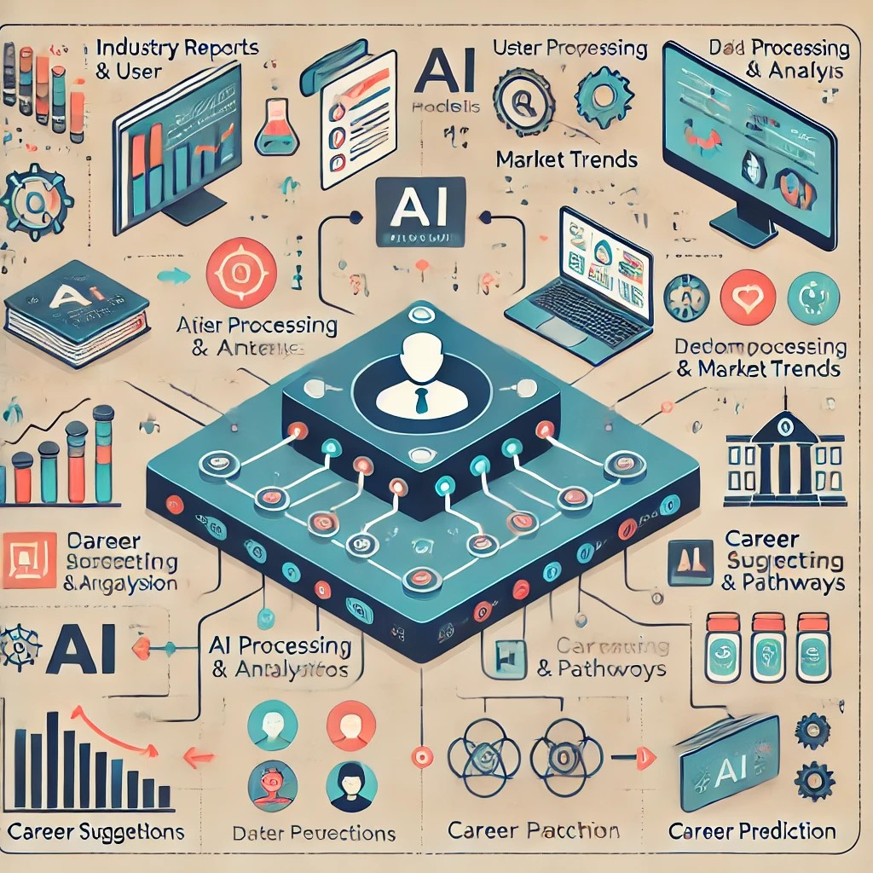

**Career Guidance AI System**

**1. Data Input (Top Section) – Where the Information Comes From**

The system collects data from:

• Industry Trends 📈 (What careers are growing?)

• User Preferences 🎯 (Student interests, skills)

• AI Data Collection 🤖 (Historical job trends, salary insights)

Purpose: To gather real-world career information.

**2. AI Processing & Analysis (Middle Section) – How AI Works**

The Machine Learning (ML) model takes the collected data and:

• Analyzes job demand 📊 (Which jobs will pay well in the future?)

• Identifies career trends 🔄 (Tech, healthcare, finance, etc.)

• Matches students with the best options 🏆

Purpose: To predict the most promising careers for users.

**3. Career Dashboard & Pathways (Bottom Section) – What Users See**

After AI analysis, the platform provides:

• Career Suggestions 💼 (Top jobs for the future)

• Exams & Universities 🎓 (Where to study, entrance exams needed)

• Learning Paths 📍 (Steps to achieve the career goal)

Purpose: To give clear career guidance with action steps.

**4. User Interaction (Final Section) – How Users Use It**

Students can:

• Explore career options 🔍 (See their future job possibilities)

• Track progress 📊 (Monitor learning & skill-building)

• Get mentorship & resources 📚 (Guidance from experts)

Purpose: To help students take action toward their dream careers.